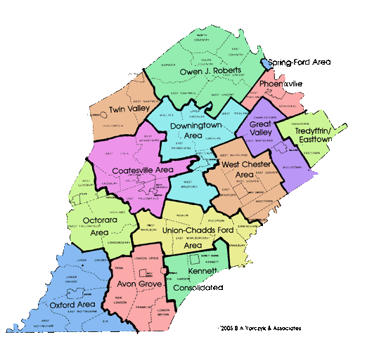
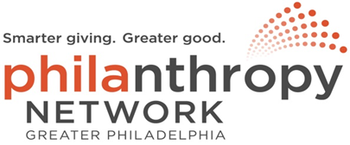

Chester County Funders Meeting
Discussion Outline
May 22, 2020
Welcome and Introductions:
- Name, Organization
- Status Update - Immediate response to COVID-19
Looking towards recovery
- Chester County Business Recovery Task Force
  - Organizational Structure
  - Input from foundation and nonprofit community
  - Priority items in progress –
    - Communications
    - Website
  - Discussion Topic -
    - What are the key issues that you feel that the County needs to address as we enter the recovery phase?
    - Key issues summary from 10-12 NPO Execs
- How is your organization approaching recovery?
  - Internally
  - Externally – i.e. considering changes in approach, grantmaking, interaction with constituents
  - From your vantage point, what are the issues that our NPOs/grantees are struggling with and/or could need assistance to address
- As we move forward, do you see any changes in the way we organize as a philanthropic cohort to address the recovery?
Philanthropy Network Update
CC Funders – Next Steps

